|  |  |
| --- | --- |
| **EXP NO:1** | **LED FLASHING WITH ARM LPC2148 MICROCONTROLLER** |
| **DATE** |

##### AIM:

To write and execute the program for LED Flashing with ARM7 (LPC2148)

Processor.

##### HARDWARE & SOFTWARE TOOLS REQUIRED:

|  |  |  |
| --- | --- | --- |
| **S.No** | **Hardware & Software Requirements** | **Quantity** |
| 1 | ARM Processor LPC2148 | 1 |
| 3 | LEDs and Resistors | 1 |
| 5 | Proteus ISIS Software and Keil Software |  |

**PROCEDURE**

* 1. Create a New project, Go to “Project” and close the current project “Close Project”.
  2. Next Go to the Project New μvision Project Create New Project Select Device for Target.
  3. Select the data base NXP LPC2148.
  4. Add Startup file and Next go to “File” and click “New”.
  5. Write a program on the editor window and save as “xxxxx.c”.
  6. Add this source file to Group and click on “Build Target” or F7.
  7. Create a Hex file from “Project” menu and click on “Rebuild all target Files”.
  8. Create the circuit diagram in Proteus Software and upload the hex file of your program by double clicking on the microcontroller in Proteus workspace.
  9. Debug and run your Proteus file to see the working of the circuit.

##### LED INTERFACING CIRCUIT DIAGRAM:

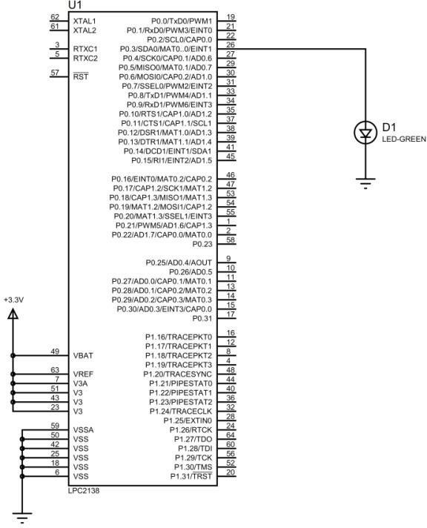

**PROGRAM:**

#include <lpc214x.h> int i;

int main()

{ IODIR0=(1<<3);

while(1)

{

IOSET0=(1<<3); for(i=0;i<120000;i++); IOCLR0=(1<<3); for(i=0;i<120000;i++);

}

}

##### FLASHING OF MORE LEDS

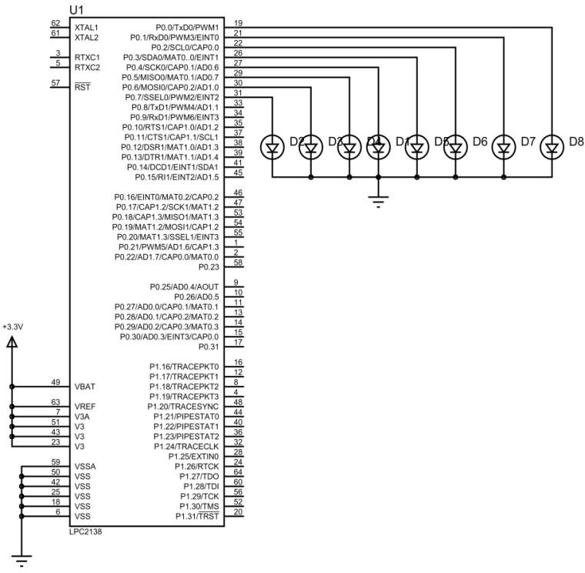

##### PROGRAM TYPE-I:

#include <lpc214x.h>

int i;

int main()

{ IODIR0=0x000000FF;

while(1)

{

IOSET0=0x000000AA; for(i=0;i<120000;i++); IOCLR0=0x000000AA; for(i=0;i<120000;i++);

}

}

##### TYPE-II:

#include <lpc214x.h>

int i,b;

int main()

{ IODIR0=0x000000FF;

while(1)

{

for(b=0;b<8;b++)

{

IOSET0=(1<<b); for(i=0;i<120000;i++); IOCLR0=(1<<b); for(i=0;i<120000;i++);

}

}

}

|  |  |
| --- | --- |
| **EXP NO:2** | **SWITCH CONTROLLED LED** |
| **DATE** |

##### AIM:

To write and execute the program for switch controlled LED with ARM7 (LPC2148)

Processor.

##### HARDWARE & SOFTWARE TOOLS REQUIRED:

|  |  |  |
| --- | --- | --- |
| **S.No** | **Hardware & Software Requirements** | **Quantity** |
| 1 | ARM Processor LPC2148 | 1 |
| 3 | LEDs and Switch |  |
| 5 | Proteus ISIS Software and Keil Software |  |

**PROCEDURE**

1. Create a New project, Go to “Project” and close the current project “Close Project”.
2. Next Go to the Project New μvision Project Create New Project Select Device for Target.
3. Select the data base NXP LPC2148.
4. Add Startup file and Next go to “File” and click “New”.
5. Write a program on the editor window and save as “xxxxx.c”.
6. Add this source file to Group and click on “Build Target” or F7.
7. Create a Hex file from “Project” menu and click on “Rebuild all target Files”.
8. Create the circuit diagram in Proteus Software and upload the hex file of your program by double clicking on the microcontroller in Proteus workspace.
9. Debug and run your Proteus file to see the working of the circuit.

##### SWITCH CONTROLLED LED CIRCUIT DIAGRAM:



**PROGRAM:**

**#include <lpc214x.h>**

**#define led (1<<2) // led label for pin 2 of port0**

**#define sw (1<<10) // sw label for pin 10 of port0**

**int main(void)**

**{**

**unsigned int x;**

**IODIR0|= (~sw); //Configure P0.10 as Input port**

**IODIR0|= led; //Configure P0.2 as Output port**

**while(1)**

**{**

**x=IOPIN0 & sw; // save status of sw in variable x**

**if(x==sw) // if switch open**

**{**

**IOCLR0|=led ; // LED off**

**}**

**else // if switch close**

**{**

**IOSET0|=led ; // LED ON**

**}**

**}**

**}**

|  |  |
| --- | --- |
| **EXP NO:3** | **7-segment LED Display with LPC2148 Microcontroller** |
| **DATE** |

##### AIM:

To write and execute the program for seven segment led with ARM7 (LPC2148)

Processor.

##### HARDWARE & SOFTWARE TOOLS REQUIRED:

|  |  |  |
| --- | --- | --- |
| **S.No** | **Hardware & Software Requirements** | **Quantity** |
| 1 | ARM Processor LPC2148 | 1 |
| 3 | 7seg LED | 1 |
| 5 | Proteus ISIS Software and Keil Software |  |

**PROCEDURE**

1. Create a New project, Go to “Project” and close the current project “Close Project”.
2. Next Go to the Project New μvision Project Create New Project Select Device for Target.
3. Select the data base NXP LPC2148.
4. Add Startup file and Next go to “File” and click “New”.
5. Write a program on the editor window and save as “xxxxx.c”.
6. Add this source file to Group and click on “Build Target” or F7.
7. Create a Hex file from “Project” menu and click on “Rebuild all target Files”.
8. Create the circuit diagram in Proteus Software and upload the hex file of your program by double clicking on the microcontroller in Proteus workspace.
9. Debug and run your Proteus file to see the working of the circuit.

##### #include <lpc214x.h>

##### void delay();

##### unsigned int i,j,k;

##### unsigned int ar[10]={0xc0,0xf9,0xa4,0xb0,0x99,0x92,0x82,0xf8,0x80,0x90};

##### 

##### int main(void)

##### {

##### IODIR0= 0x000000FF; //Configure P0.0 -P0.7 as output port

##### 

##### while(1)

##### {

##### for(i=0;i<10;i++)

##### {

##### IOSET0= ar[i];

##### delay();

##### IOCLR0=ar[i];

##### }

##### }

##### return 0;

##### }

##### void delay()

##### { for (j=0;j<1000;j++)

##### for (k=0;k<400;k++);

##### }

##### 

##### 

##### 

|  |  |
| --- | --- |
| **EXP NO:4** | **TIMERS** |
| **DATE** |

[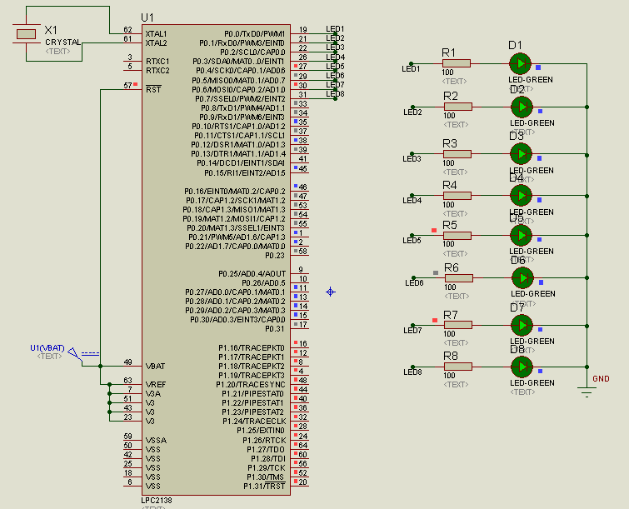](https://2.bp.blogspot.com/-kvYj51t0uas/WaekoWA4irI/AAAAAAAAAIQ/Lf4O8y4SaKITA97ytJhlrjzVlx3ZSc7xQCEwYBhgL/s1600/2.array+of+leds.png)

**PROGRAM;**

#include <LPC214x.H>

void timer_sec(unsigned int x)

{

T0MR0 = x;

T0MCR = 1;

T0PR = 0x00E4E1C0;

T0TCR = 0x1;

while(T0TC < T0MR0);

T0TCR = 0x0;

T0TC = 0x0;

}

int main (void)

{

unsigned int n;

PINSEL2=0x00000000;

IODIR0 = 0x00FF;

while (1)

{

IOSET0 = 0x00FF;

timer_sec(1);

IOCLR0 = 0x00FF;

timer_sec(1);

}

}

|  |  |
| --- | --- |
| **EXP NO:5** | **DC Motor Interfacing** |
| **DATE:** |

**AIM:**

To design a circuit and develop a C program for controlling a DC motor.

**HARDWARE AND SOFTWARE REQUIRED:**

|  |  |  |
| --- | --- | --- |
| **S.No** | **Hardware & Software Requirements** | **Quantity** |
| 1 | ARM Processor LPC2148 | 1 |
| 2 | L293D IC | 1 |
| 3 | Proteus Software and Keil Software | - |
| 4 | Simple DC Motor active | 1 |

**CIRCUIT DIAGRAM:**



**PROGRAM:**

#include <lpc214x.h>

void delay();

unsigned int j,k;

void main(void)

{

IO0DIR=0x03;

while(1)

{

IOSET0 = (1<<0);

IOCLR0=(1<<1) ;

delay();

delay();

delay();

delay();

IOCLR0=0x03;

delay();

delay();

delay();

delay();

IOSET0 = (1<<1);

IOCLR0=(1<<0) ;

delay();

delay();

delay();

delay();

IOCLR0=0x03;

delay();

delay();

delay();

delay();

}

}

void delay()

{ for (j=0;j<1000;j++)

for (k=0;k<400;k++);

}

|  |  |
| --- | --- |
| **EXP NO:6** | **Stepper Motor Interfacing with LPC2138** |
| **DATE:** |

**AIM:**

To design and develop a C program for interfacing Stepper Motor with LPC2138.

**HARDWARE AND SOFTWARE REQUIRED:**

|  |  |  |
| --- | --- | --- |
| **S.No** | **Hardware & Software Requirements** | **Quantity** |
| 1 | ARM Processor LPC2138 | 1 |
| 2 | ULN2003A | 1 |
| 3 | Proteus Software and Keil Software | - |
| 4 | Stepper Motor Animated Unipolar. | 1 |

**PROCEDURE:**

1. Create a New project, Go to “Project” and close the current project “Close Project”.

2. Next Go to the Project New μvision Project Create New Project Select Device forTarget.

3. Select the data base NXP LPC2148.

4. Add Startup file and Next go to “File” and click “New”.

5. Write a program on the editor window and save as “Main.c”.

6. Add this source file to Group and click on “Build Target” or F7.

7. Create a Hex file from “Project” menu and click on “Rebuild all target Files”.

8. Open Flash magic and select the device LPC2148 in ARM 7

9. Next browse the path of hex file and click ok.

10.Start debugging process and run the simulation for getting output.

**CIRCUIT DIAGRAM:**

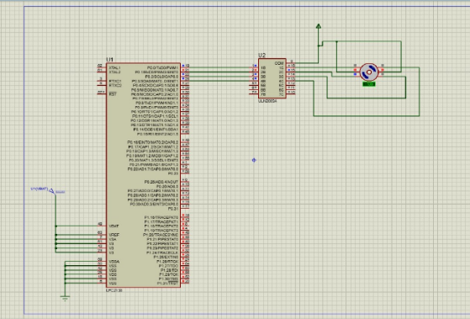

**PROGRAM:**

